

30 May 2018

REPORT TITLE AND HEADLINE

PREPARED BY SELWYN PEARTON
RESEARCH & DEVELOPMENT MANAGER

table of contents

REPORT TITLE AND HEADLINE 0
table of contents 1
header standard paragraph 2
1.1 introduction 3
2 | BLAST AUDIT - BASE CASE, EXPANFO 300 3

header standard paragraph
Subheading style

Body copy style 2.
In order to allow for the comparison of Megapump emulsion and Expanfo 300 in stoping operations on Tumela mine, a blast audit was undertaken on Expanfo 300 on 8 level 36/5W panel prior to the introduction of Megapump emulsion. During the blast audit a total of 11 blasts were undertaken. Eight according to existing mine practices followed by three with the use of Bintech stemming. Throughout the blast audit it was evident that drilling and blasting practices on the panel deviated from mine standard and an average advance of only 0.68m was achieved per blast through the use of Expanfo 300.

While Megapump emulsion was first implemented in place of Expanfo 300 on the 23rd October, closure of the 36/5W panel due to a fault resulted in only two blasts being undertaken on the panel prior to closure. This prevented comparison of Expanfo and Megapump emulsion blast results on the same panel and facilitated a three week delay in blasting while a new panel was established for the trial.

Following the relocation of the BME team to the new panel, inadequate change management and resistance to change by underground personnel slowed progress on the 36/6W panel and it again became necessary for the Megapump emulsion trial to be relocated to 37/4E panel. As the team operating on 37/4E panel is the team that originally operated on 36/5W panel, the initial cooperation by the team has been positive.

1.1 introduction

The following report is based on blast audits conducted underground at Tumela Lower 1#, section 114, 8 Level, x/cut 36 panel 5 West from the 11th September to the 21th October 2013. Over this period, a total of only eleven Expanfo blasts were audited due to labour unrest and strikes on the mining operation. This report highlights the drilling and blasting practices experienced on the 5W panel together with the blast results achieved over the period for the audit.

Following a discussion of the blasting practices and results achieved in the base case, the progress and challenges experienced in the initial implementation of the Megapump emulsion system on Tumela mine will be discussed.

2 | BLAST AUDIT - BASE CASE, EXPANFO 300
2.1 Marking Practices

Marking plays a vital role in the success of daily drilling and blasting operations. A poorly marked round will result in a round poorly drilled round thus decreasing the possible advance and blasting efficiency that can be achieved through the round. Drill operators require clearly marked panels to assist them in drilling burdens and spacings to mine standard. In addition, direction lines need be clearly marked to guide operators so that blastholes are drilled in the required direction and elevation. Over the duration of the blast audit marking practices have been inconsistent and not according to the prescribed mine standard. The average size of burdens marked during the trial has varied from 40cm to 70cm in size while spacings from 45cm to 70cm have also been experienced.

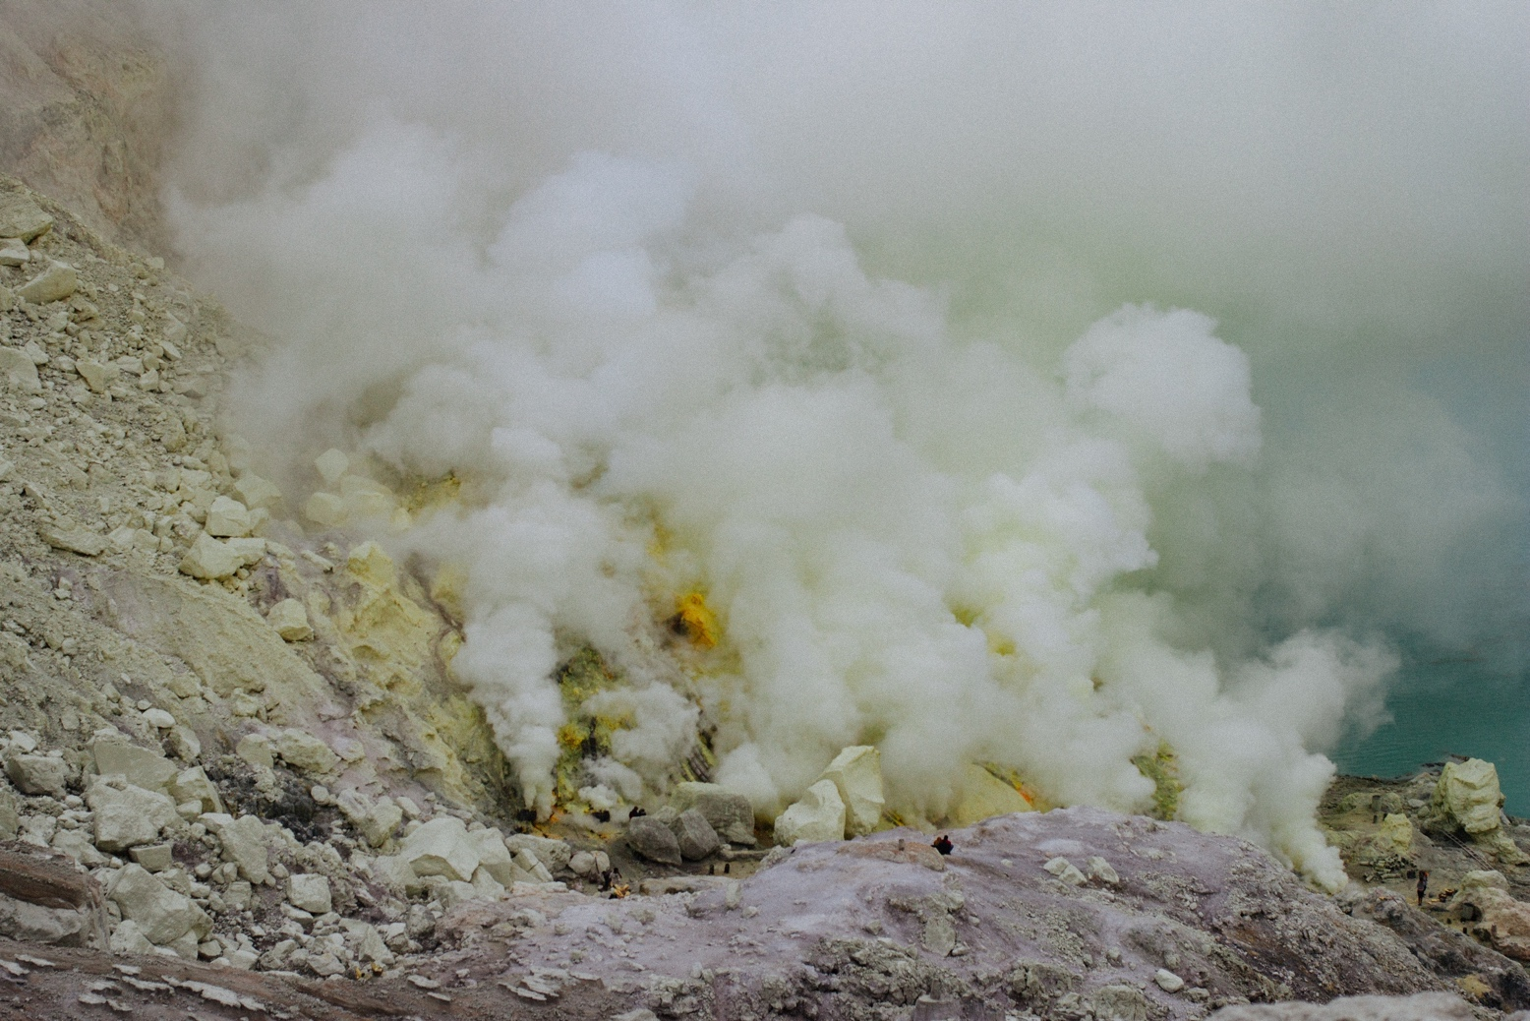
Caption style


Caption style

